**LINK FIGMA ASLI:**

[**https://www.figma.com/design/wZFIm23flKnZ15gQF7koRE/2702300120---HCI-LAB-PROJECT?node-id=0-1&t=Dhb5tttXQZxbOb3X-1**](https://www.figma.com/design/wZFIm23flKnZ15gQF7koRE/2702300120---HCI-LAB-PROJECT?node-id=0-1&t=Dhb5tttXQZxbOb3X-1)

**LINK FILE FIGMA (.fig) ONE DRIVE:**

[2702300120 - Michael Ivan S - HCI LAB PROJECT.fig](https://binusianorg-my.sharepoint.com/personal/michael_santoso005_binus_ac_id/_layouts/15/guestaccess.aspx?share=EdrBaOM2kzdHjPQiDPqy0yIBg--oYH5GAWCuNcxjKPFZLQ&e=WTgX7U)

**LINK FILE FIGMA (.fig) GOOGLE DRIVE:**

[**https://drive.google.com/file/d/1E37zhApv4VyVlHRRj4J1RkQ_YRLlM3Uc/view?usp=sharing**](https://drive.google.com/file/d/1E37zhApv4VyVlHRRj4J1RkQ_YRLlM3Uc/view?usp=sharing)

**Link Gambar**

**Gambar background 1:**

<https://pin.it/6zdzRGk3A>

**Gambar CNY Set:**

<https://pin.it/23jdK5CoG>

**Gambar Lunch box:**

<https://pin.it/6zf9ZTDj5>

**Gambar diskon 40%:**

<https://png.pngtree.com/png-vector/20221116/ourmid/pngtree-40-percent-discount-tags-png-image_6463531.png>

**Gambar diskon 20%:**

<https://png.pngtree.com/png-vector/20220527/ourmid/pngtree-yellow-20-discount-big-sale-offer-banner-png-image_4743001.png>

**Gambar Our Story:**

<https://pin.it/6dNAeGner>

**Gambar Party Set:**

<https://www.istockphoto.com/id/foto/meja-acara-pernikahan-makanan-katering-gm650655146-118180751>

<https://media.istockphoto.com/id/650655146/id/foto/meja-acara-pernikahan-makanan-katering.jpg?s=612x612&w=0&k=20&c=XjpCf4IQ7TzTJAlrY8-268y1i_dYmIyCPlTSODRzRSQ=>

**Gambar Regular Set:**

<https://id.pinterest.com/pin/890164682567096395/>

**Gambar Kids Meal:**

<https://www.bentocatering.id/menu/menu-anak>

<https://www.bentocatering.id/wp-content/uploads/2018/11/menu-bento-tupperware.jpg>

**Gambar Mr Moyai:**

<https://pin.it/4RsgjJim4>

**Gambar Meme:**

<https://pin.it/6HbAvIa9p>

**Gambar Pig:**

<https://knowyourmeme.com/memes/yaman>

**Gambar Sanji:**

<https://pin.it/Pt5IO6q24>

**Gambar affordable price:**

<https://vectorpic.com/15-tips-for-starting-a-graphic-design-business.html/affordable-prices>

**Gambar fresh ingredients:**

<https://thenounproject.com/browse/icons/term/fresh-ingredients/>

**Gambar professional chef:**

<https://freeicons.io/different-profession-icons/profession-chef-icon-icon>

**Gambar bite:**

<https://thenounproject.com/browse/icons/term/bite/>

**Gambar cart:**

<https://images.app.goo.gl/mnZs5ZFWdeqhdHfG9>

**Gambar icon social media:**

<https://www.figma.com/design/ukZg6yvNCg4iz7LKtvqBuA/25-Social-Media-Icons-(Community)?m=auto&t=Suplmmg4O077NxQr-6>

**Gambar icon calendar, check, arrow button:**

<https://www.figma.com/design/PzduYx52hOztXi93qPc0XO/1%2C000-Free-UI-UX-Icons---Download-vector-svg-and-png-icons-(Community)?m=auto&t=Suplmmg4O077NxQr-6>

**Sisanya bikin sendiri manual..**

**DOCUMENTATION**

Setiap page akan selalu memiliki nav bar yang ada button untuk ke page lainnya dan juga footer yang ada button berupa logo media sosial untuk menuju web media sosial

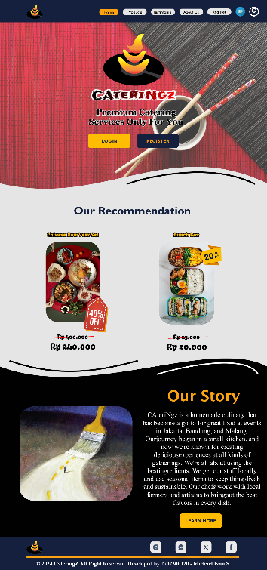

Home Page:

Pada section 1 ada 2 button untuk mengarah ke login dan register page

Pada section 2, saat user menekan product langsung diarahkan ke cart page

Pada section 3 ada button learn more untuk ke about us page

Products page:

Berisi gambar, penjelasan, dan harga product. Jika user menekan product maka dibawa ke cart page

Testtimonial Page:

Berisi testimoni dan rating saja

About us page:

Berisi penjelasan tentang cateringz dan ada button di bawah berisi media sosial dan kontak cateringz

Register page:

Berisi input container agar user dapat mengisi setiap data dan juga tombol register untuk finalisasi dan membawa ke profile.html jika berhasil

Login page:

Berisi input container untuk user mengisi username dan password. Tombol login digunakan untuk eksekusi sementara register akan membawa ke register page

Cart page:

Hanya dapat diakses jika user sudah login. Berisi semua product berisi gambar, penjelasan, dan harga. User dapat memilih quantity dan melihat total harga secara langsung lalu tombol confirm untuk membeli

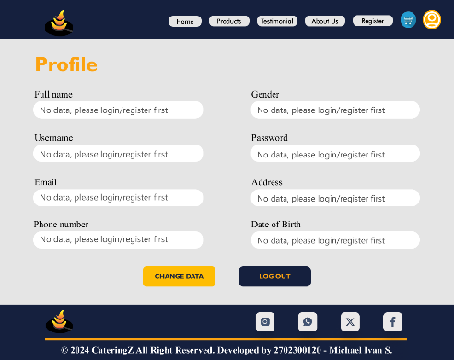Profile Page:

Hanya dapat diakses jika user sudah login. Berisi semua data dari logged user dan ada button change data agar user dapat merubah data di register page dan juga logout agar user dapat logout.